**Sequence Diagrams**

**1. Search for Species/Display Results**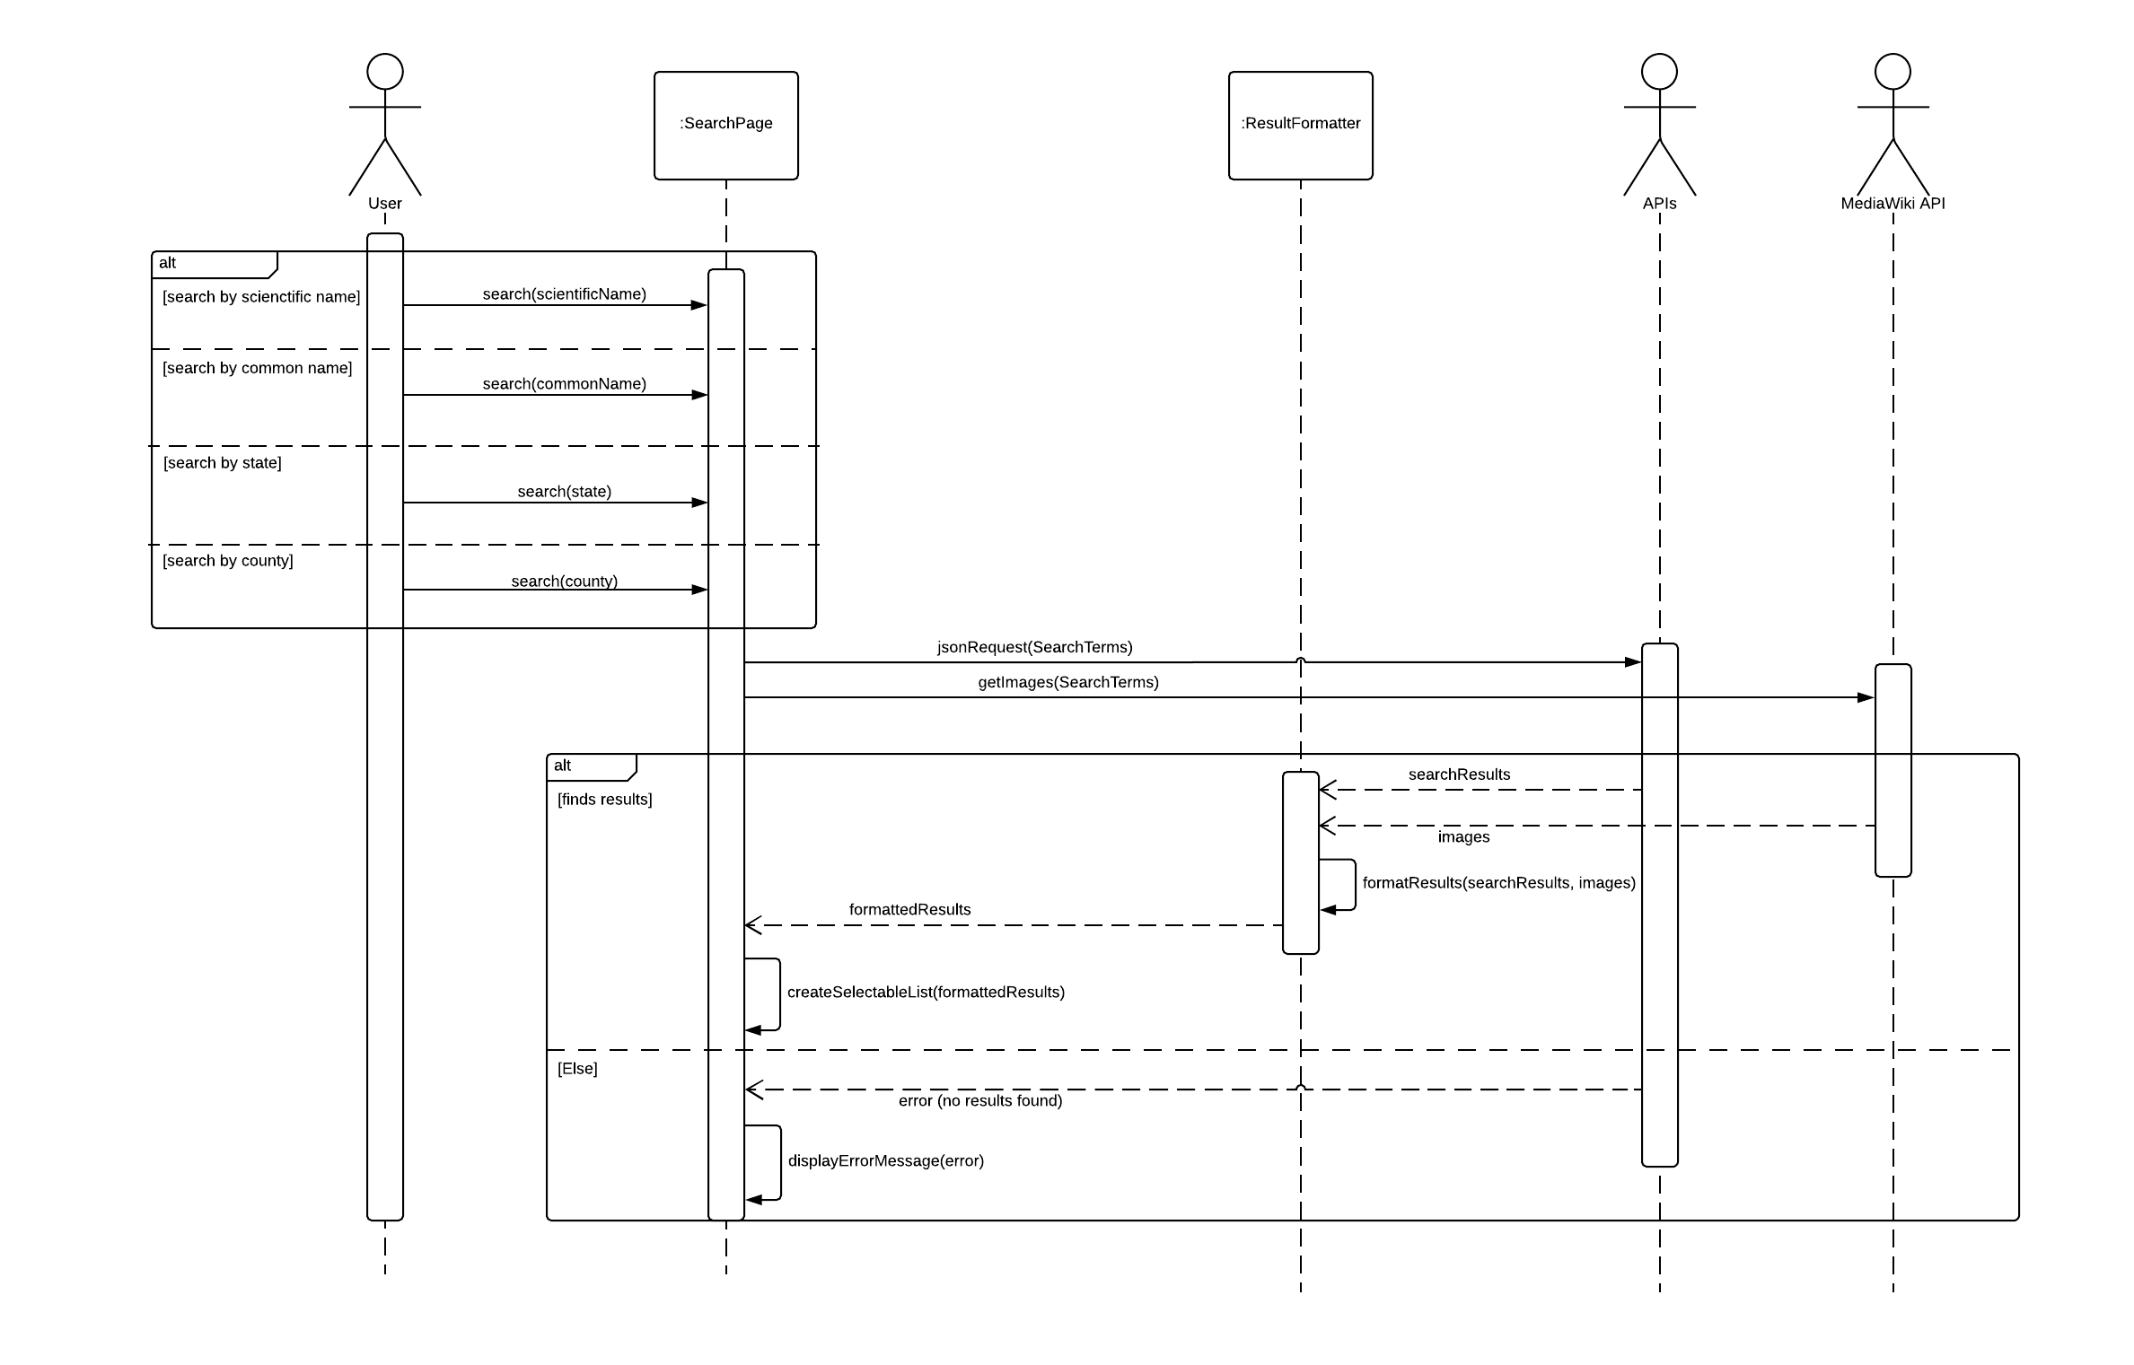

**2. Filter by location, taxonomic, date, and habitat**

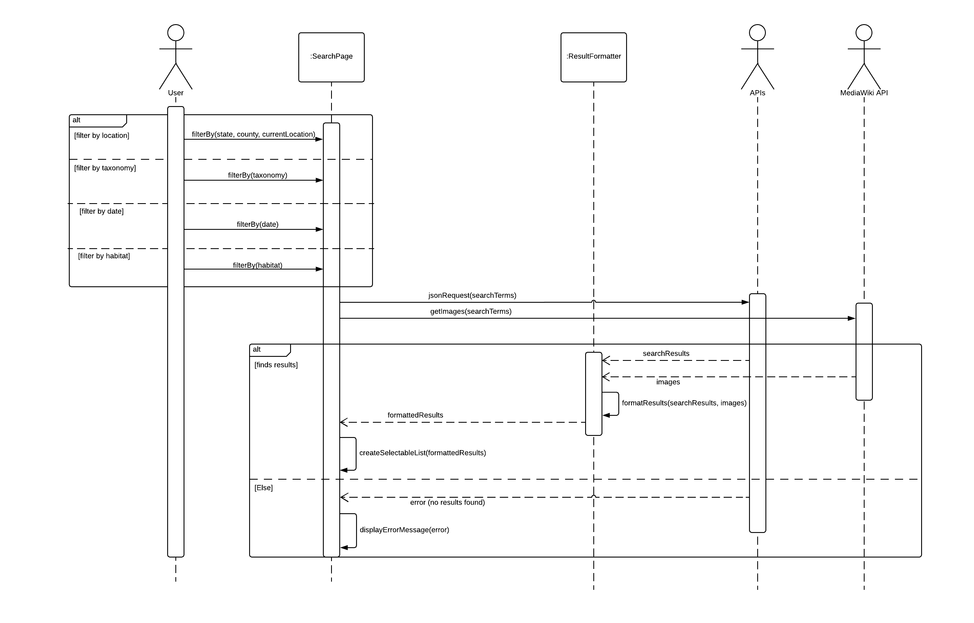

**3. Search for Species Using “What’s Around Me” Button**

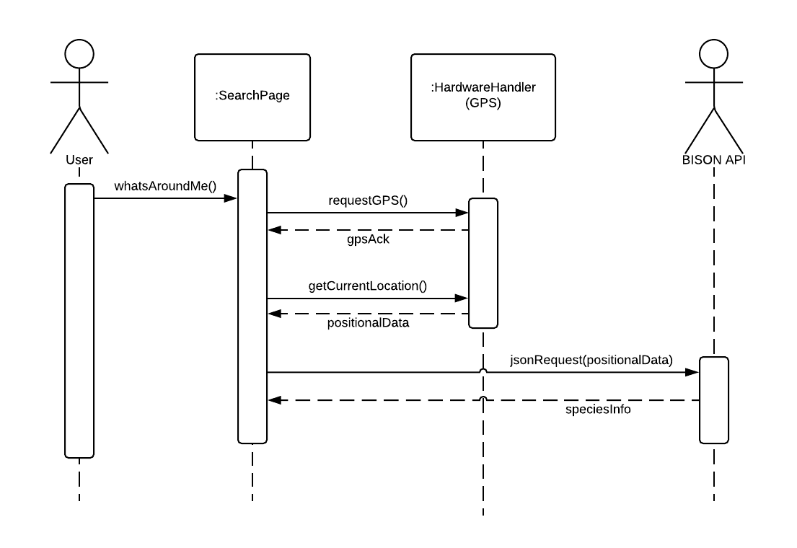

**4. Store User’s Past Searches**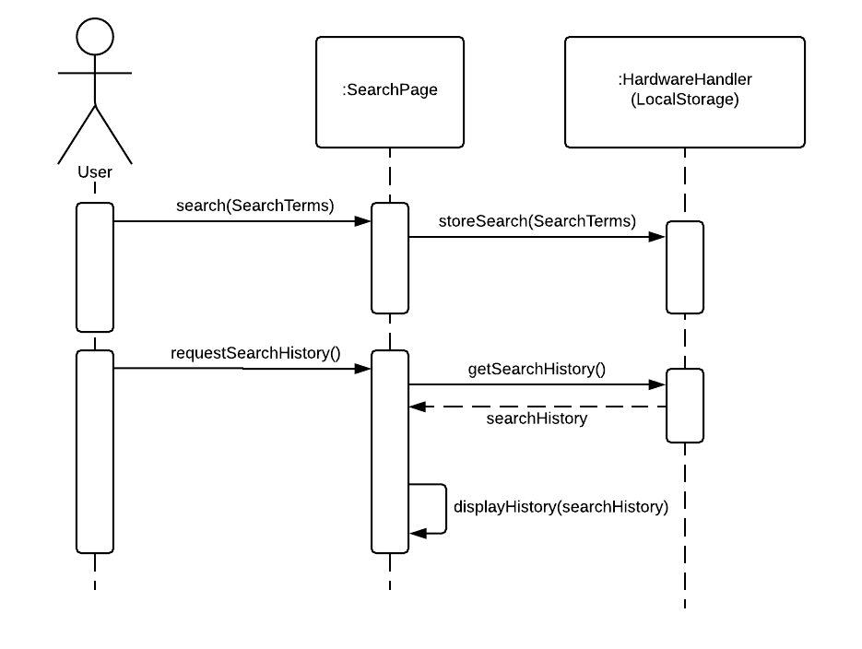

**5. View More Information/Provide Additional Information/View Credit of Information**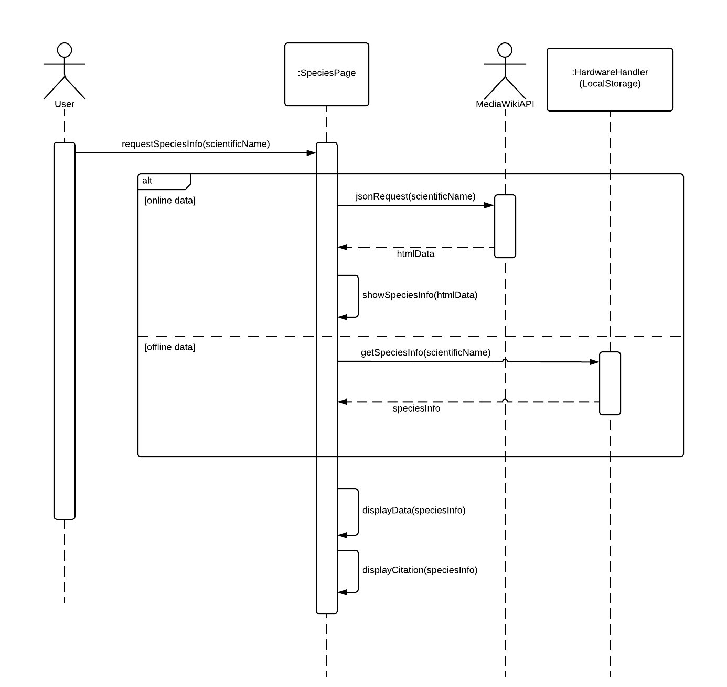

**6. Save Images of Species**

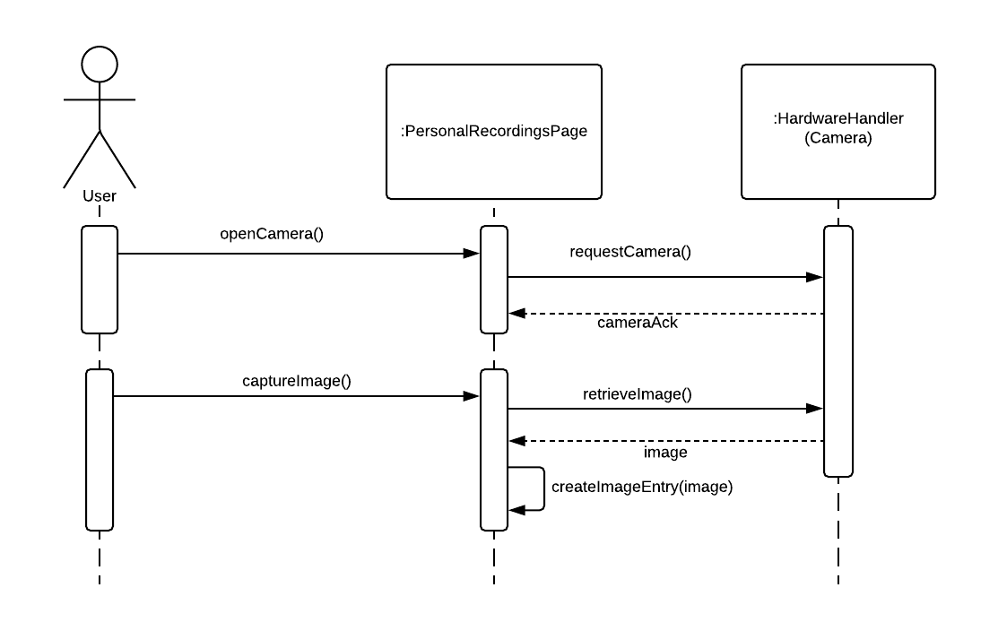

**7. Save Audio Recordings of Species**

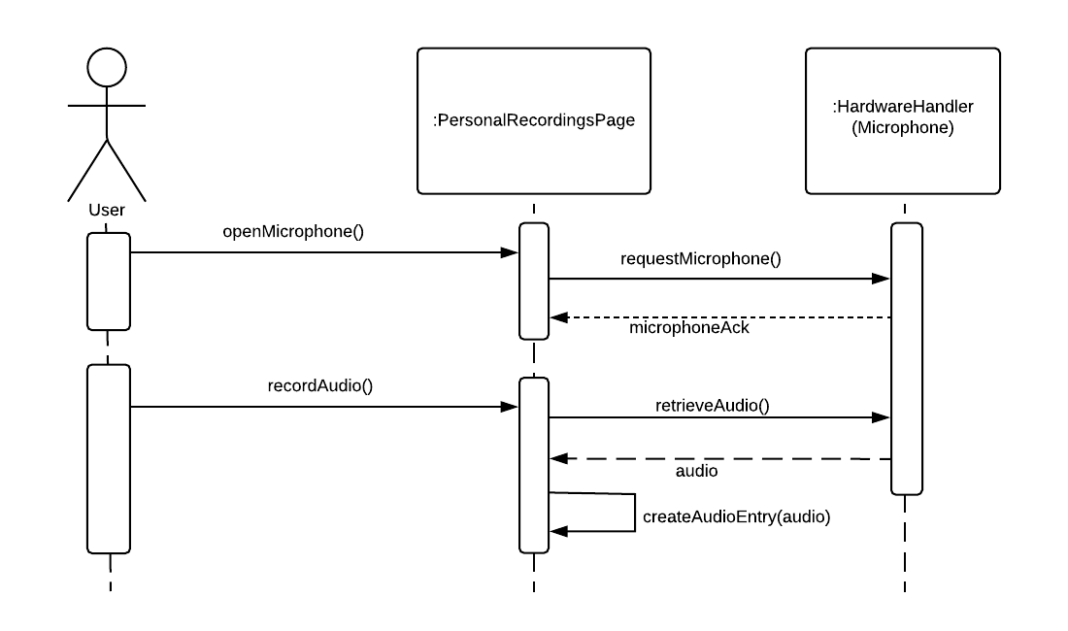

**8. Record Location of Observation of Species**

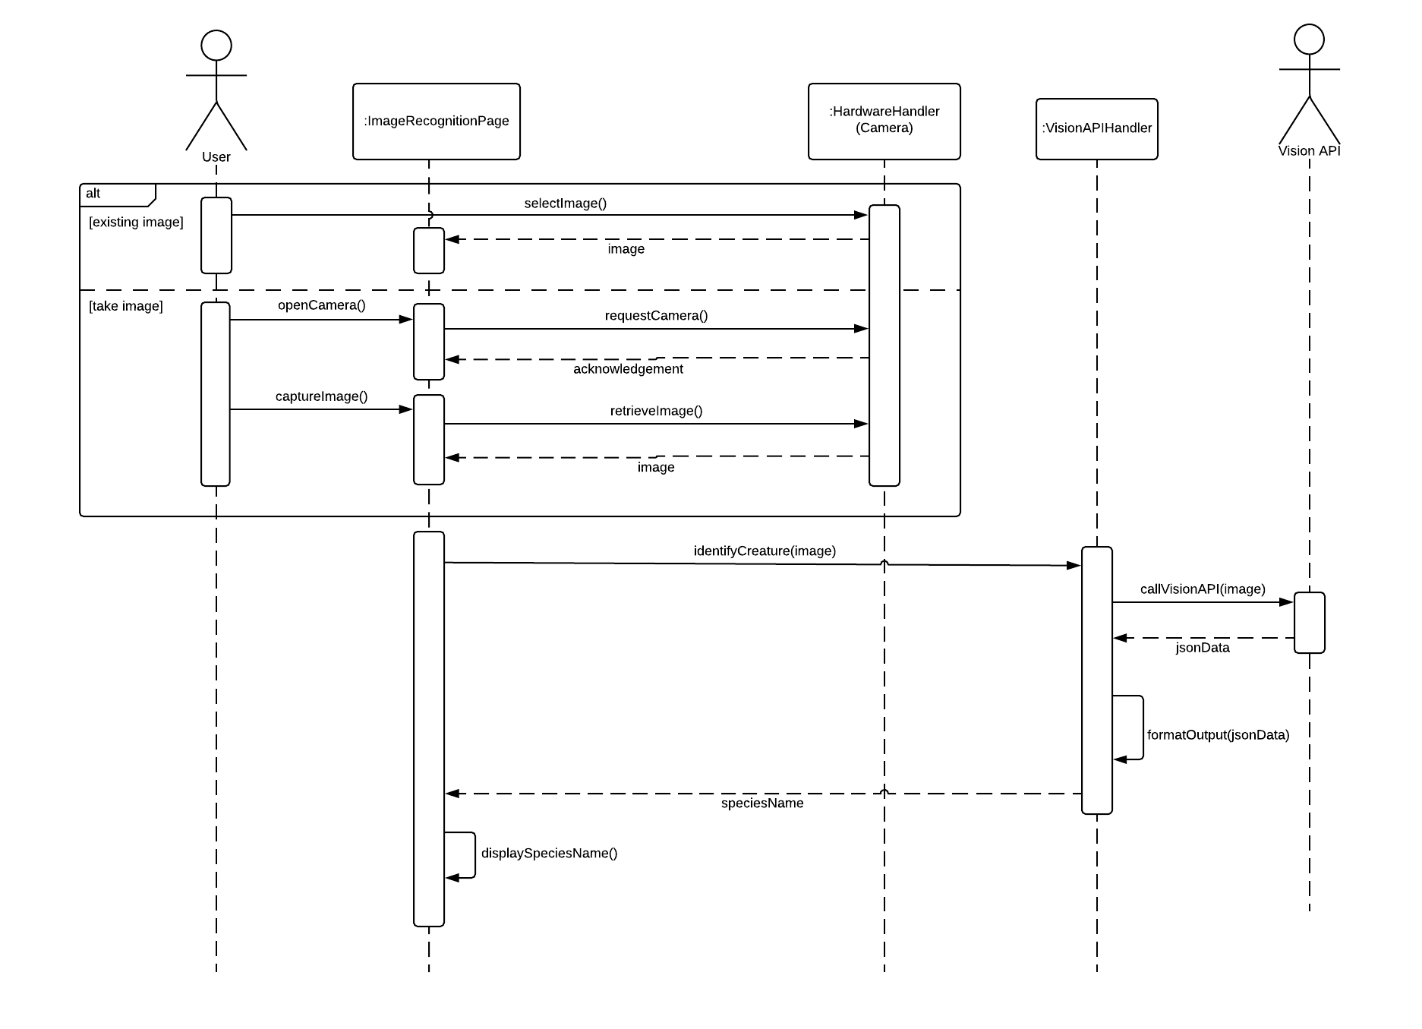

**9. Group Saved Images, Audio Recordings, and Locations**

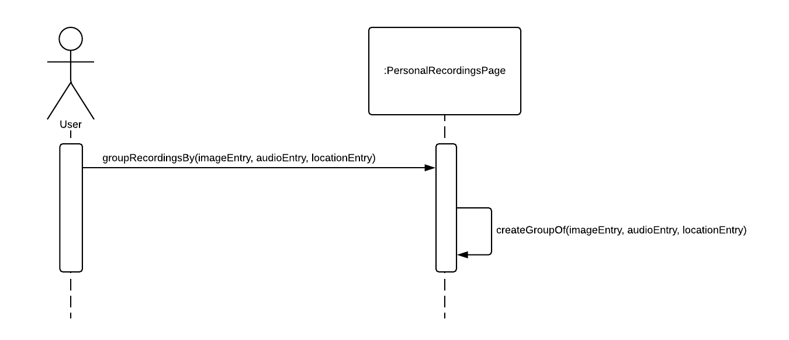

**10. Download Data for Offline Use/Place Data Within Local Storage**

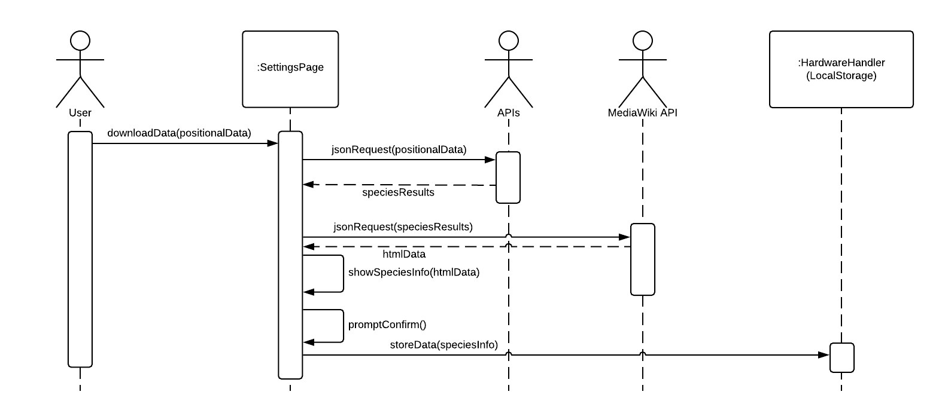

**11. Toggle the Display of Preview Images**

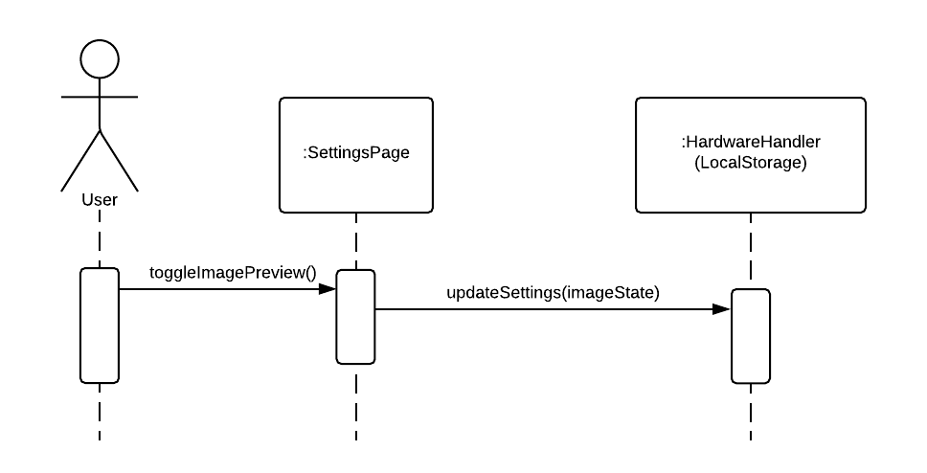

**12. Clear Search History**

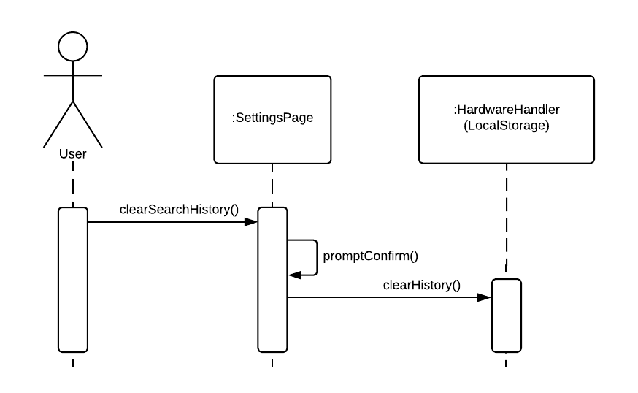

**13. Clear Downloaded Cache**

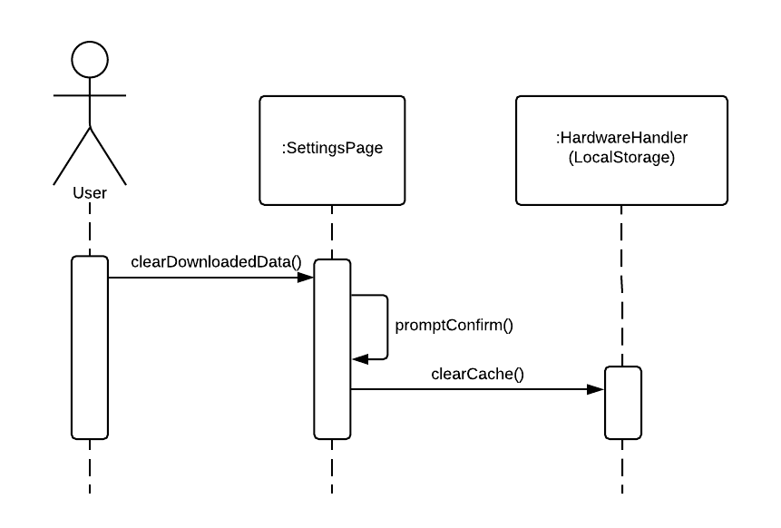

**14. Change Search Distance**

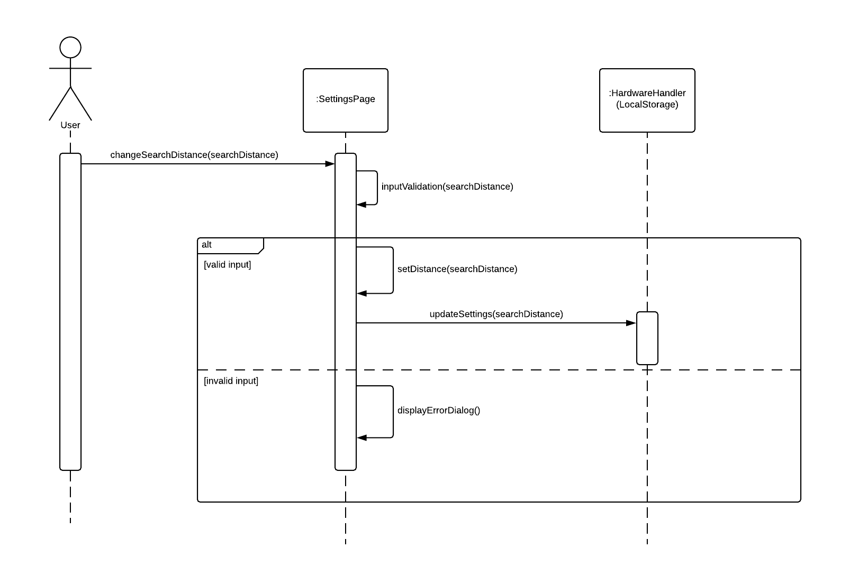

**15. View Observations of Certain Species on a Map/Provide Species Information about an Observation/Render Map of Observation**

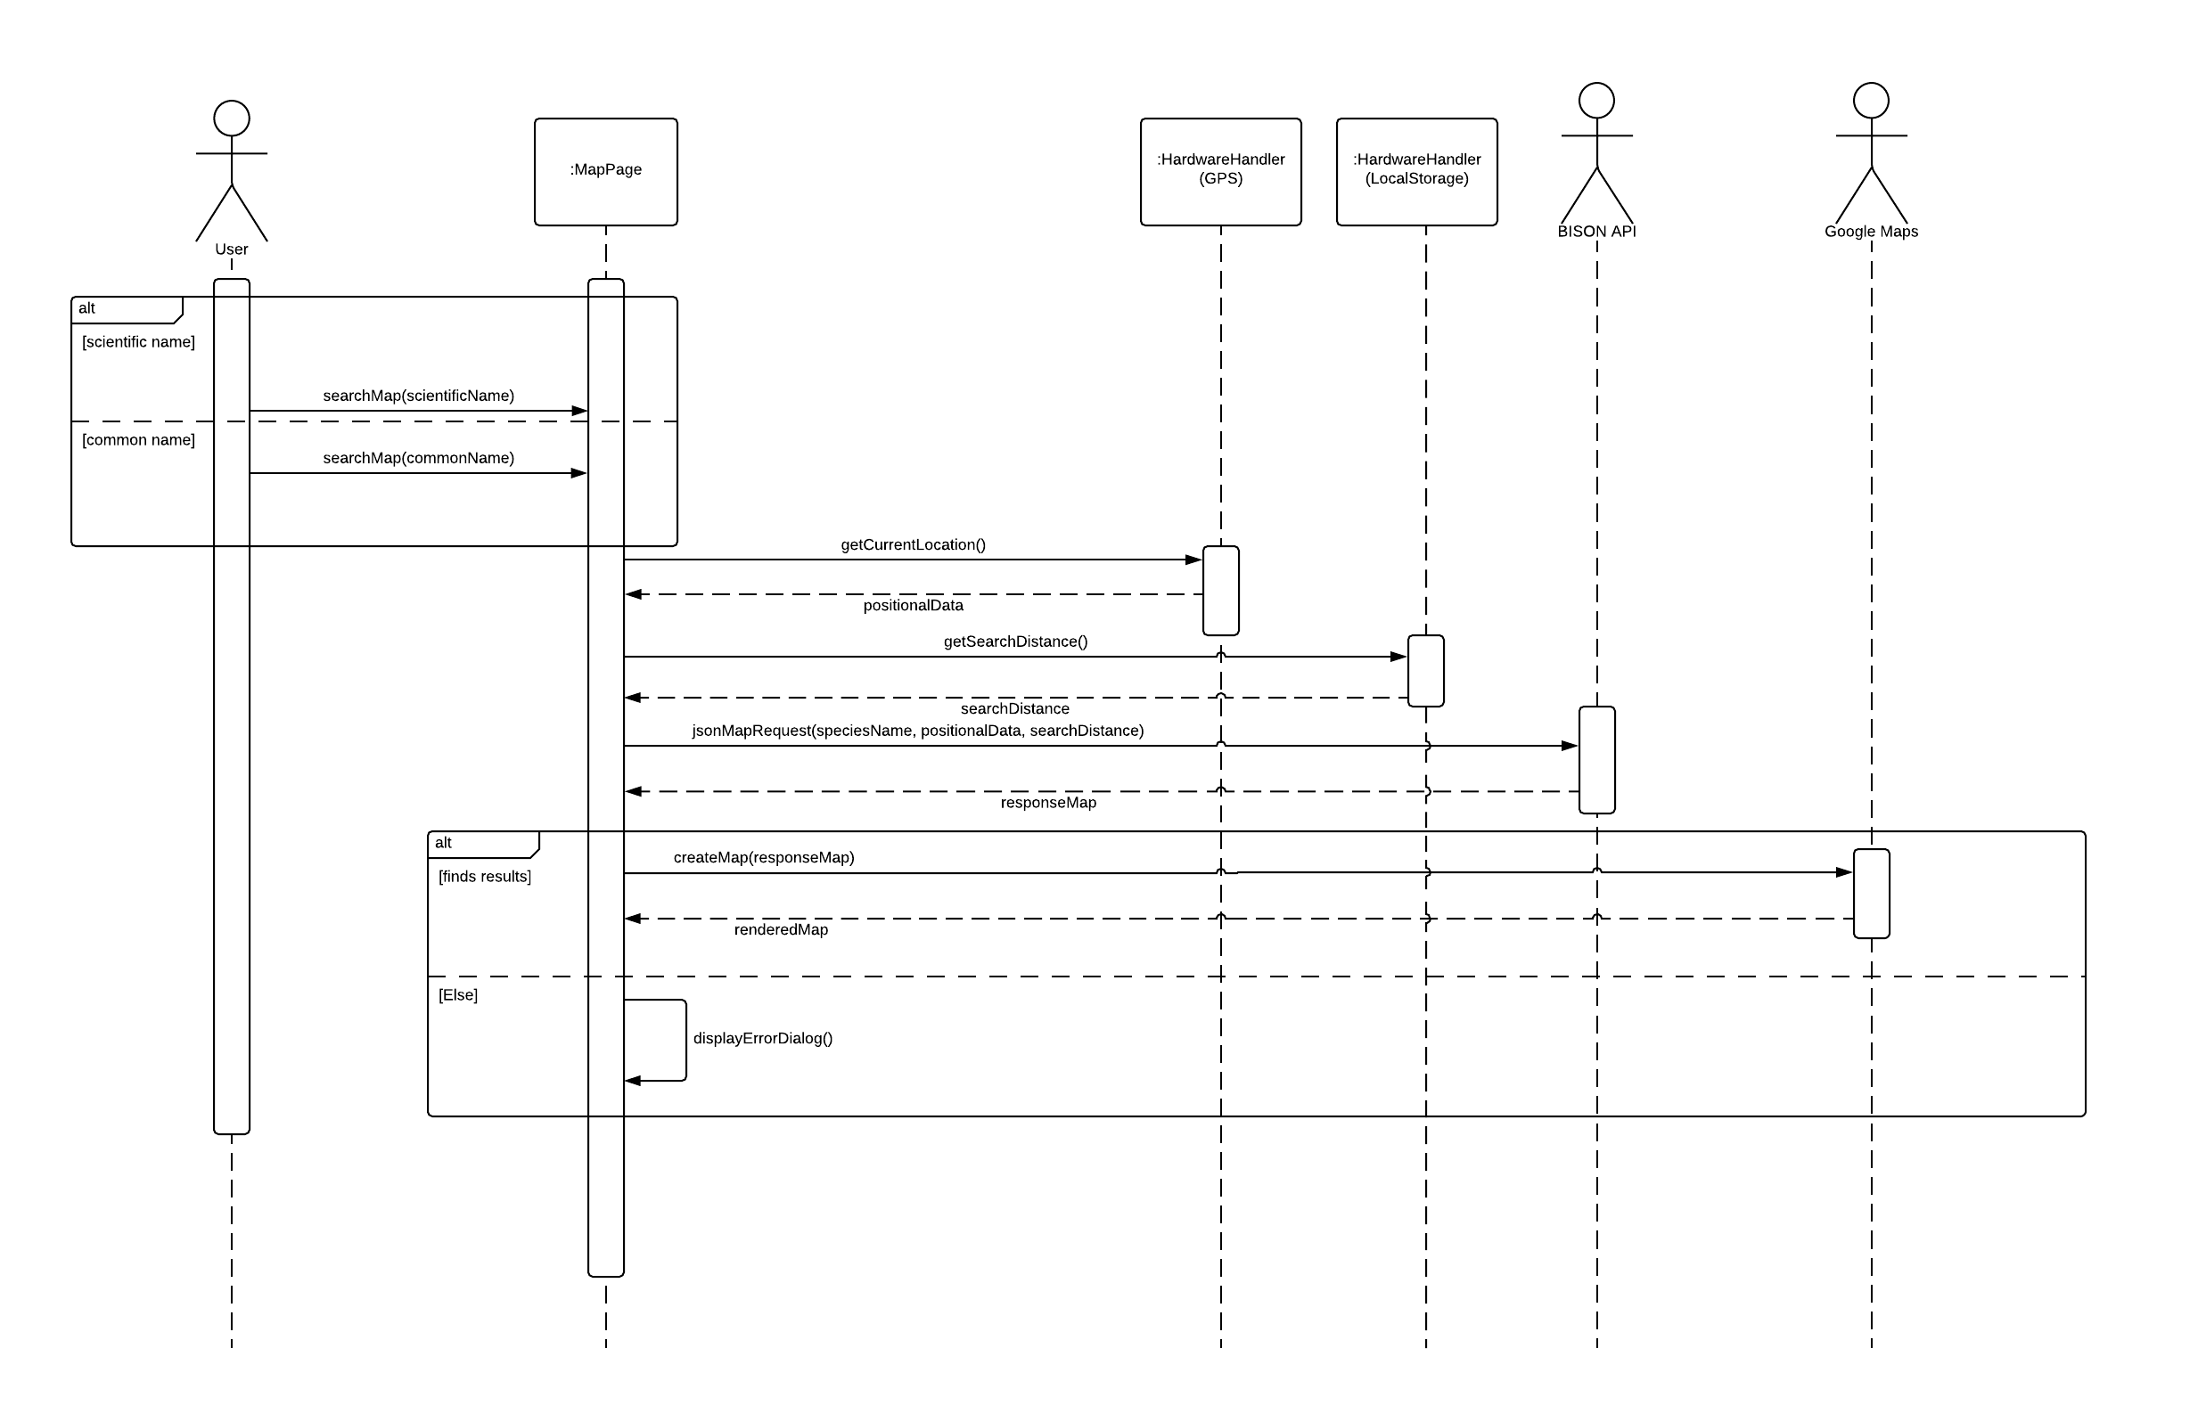

**16. Select Observation on Map**

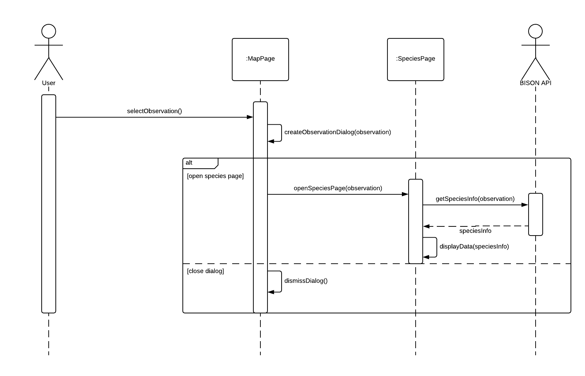

**17. Redirect to the Home Screen if the Application banner is clicked/View Help Page/View Settings Page**

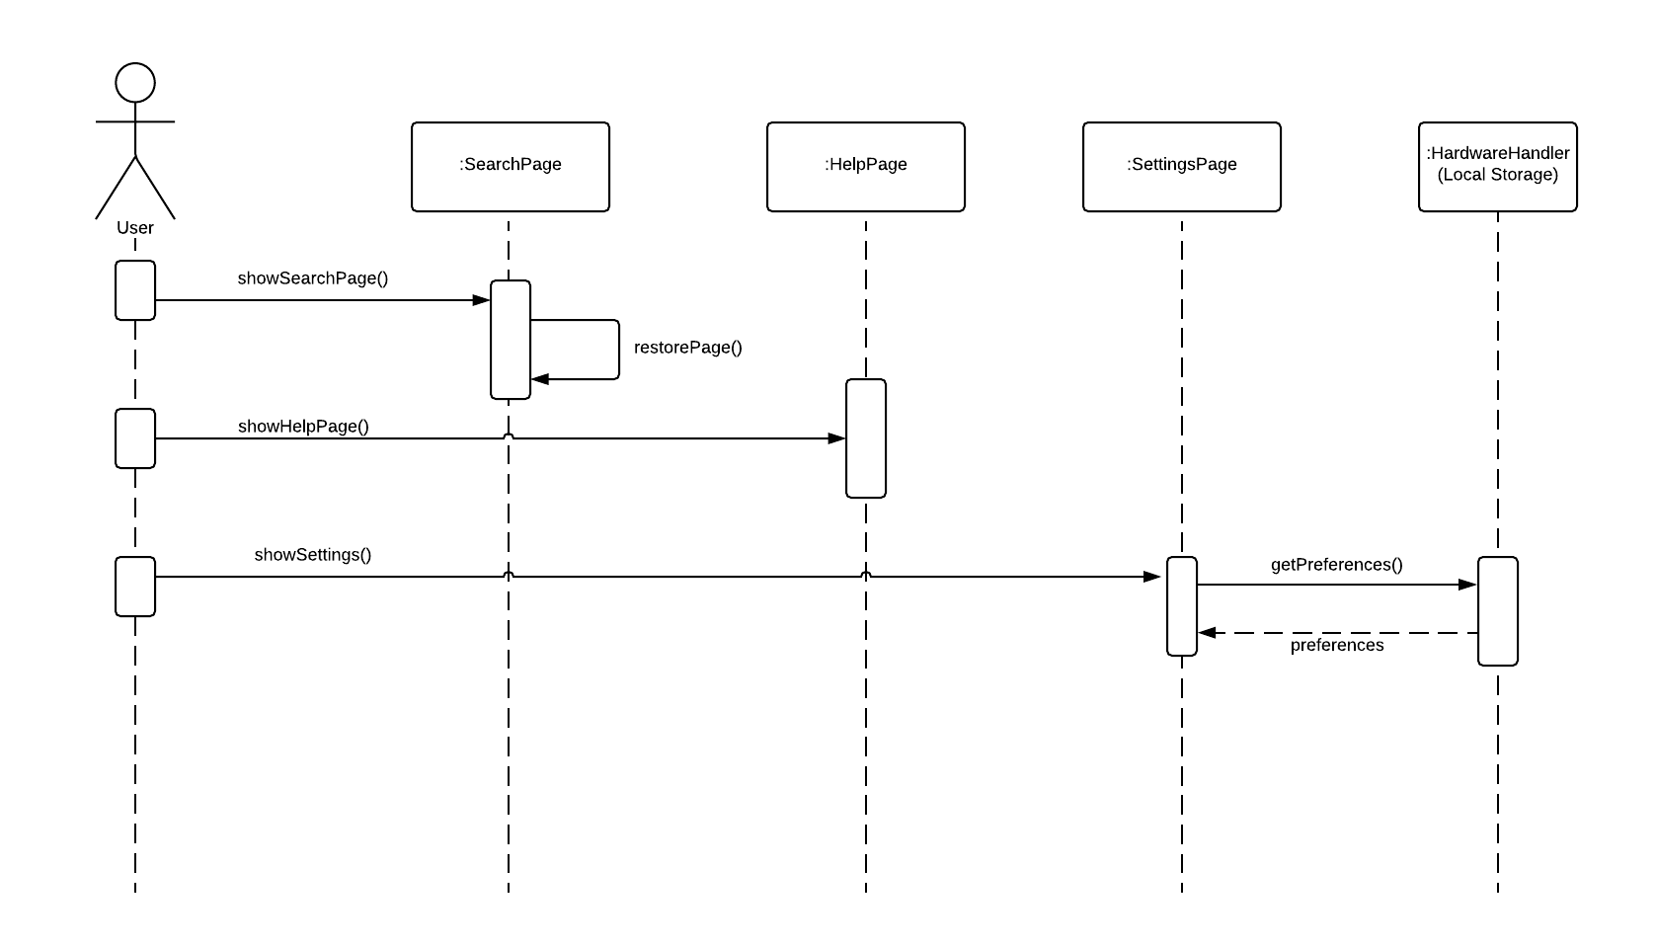

**18. Perform Image Recognition on Image**

